St. Francis Institute of Technology, Mumbai-400 103
Department Of Information Technology
A.Y. 2025-2026

Class: SE-ITA/B, Semester: IV Subject: DevOps Lab
Experiment – 8: To execute test cases on a browser using Selenium IDE and set up and run Selenium tests in Jenkins using Maven.
- Aim: To execute test cases on a browser using Selenium IDE and set up and run Selenium tests in Jenkins using Maven.
- Objectives: Aim of this experiment is that, the students will learn:
  - Selenium and how to automate your test cases for testing web elements
- Outcomes: After study of this experiment, the students will learn following:
  - Introduction to Selenium
  - Installing Katalon (Selenium Tests generator)
  - Creating Test Cases in Selenium WebDriver
  - Run Selenium Tests in Jenkins Using Maven
- Prerequisite: Knowledge of Software Engineering concept of testing and test cases.
5. Requirements: Jenkins, JDK, Eclipse IDE, Chrome browser, Personal Computer, Windows operating system, Internet Connection, Microsoft Word.

Pre-Experiment Exercise:
Brief Theory: Refer shared material
- Laboratory Exercise
  - Procedure:
    - Answer the following:
      - Explain Selenium suite?
      - What are the limitations of Selenium IDE?

Execute following (Refer the shared material) and attach screenshots:
      - Create and run a test case on Chrome/Firefox browser with Katalon Recorder( selenium tests generator) IDE addon
      - Create a Maven Project in Jenkins and run selenium tests using selenium Grid

Post-Experiments Exercise
  - Extended Theory:
Nil

Questions:
- What are Locators? Explain its types.
- What is the benefit of using Selenium Grid with Jenkins?

Conclusion:
- Write what was performed in the experiment.
- Write the significance of the topic studied in the experiment.

References:
https://jenkins.io/doc/ https://www.slideshare.net/abediaz/introduction-to-jenkins https://q-automations.com/2019/09/26/selenium-grid-with-jenkins/

- Laboratory Exercise
  - Procedure:
    - Answer the following:

- Explain Selenium Suite
The Selenium Suite is a collection of tools used for automating web applications for testing purposes. It is widely used for functional and regression testing of web applications across different browsers and platforms. The suite consists of the following components:

Selenium IDE (Integrated Development Environment)
    - It is a browser extension (mainly for Chrome/Firefox) used for recording and playback of test cases.
    - It is beginner-friendly and does not require programming knowledge.
    - Useful for quick prototyping of test scripts.

Selenium WebDriver
    - It is the most important component of the Selenium suite.
    - It allows writing test scripts in multiple programming languages like Java, Python, C#, etc.
    - It directly interacts with the browser and provides better control and performance compared to Selenium IDE.
  - Selenium RC (Remote Control) (Deprecated)
    - Earlier used to run tests in different browsers using a server.
    - Now replaced by WebDriver due to limitations like slower execution and complex architecture.

Selenium Grid
    - Used to run tests on multiple machines and browsers simultaneously.
    - Helps in parallel execution, reducing testing time.
    - Useful for cross-browser and distributed testing.
Overall, the Selenium Suite provides flexibility, scalability, and support for multiple environments, making it a powerful tool for web application testing.

Limitations of Selenium IDE
Although Selenium IDE is easy to use, it has several limitations:

Limited to Browser Automation Only
    - Selenium IDE can only automate web applications.
    - It cannot test desktop applications or mobile apps.

No Advanced Programming Logic
    - It does not support complex logic like loops, conditions, or data-driven testing effectively.
    - This limits its use for large-scale testing.

Lack of Reusability and Maintainability
    - Test scripts created in Selenium IDE are not easily reusable.
    - Maintenance becomes difficult as test cases grow.

Limited Browser Support
    - Mainly supports Chrome and Firefox.
    - Not suitable for extensive cross-browser testing.

No Integration with Testing Frameworks
    - Cannot integrate with frameworks like TestNG or JUnit directly.
    - This restricts structured test execution and reporting.

Weak Error Handling and Debugging
    - Provides limited debugging capabilities.
    - Difficult to handle dynamic elements or unexpected failures.

Not Suitable for Large Projects
    - Works well for small or simple test cases.
    - Not recommended for enterprise-level or complex automation.
In summary, Selenium IDE is useful for beginners and quick testing, but for advanced and scalable automation, Selenium WebDriver is preferred.

Jenkins Manage Jenkins
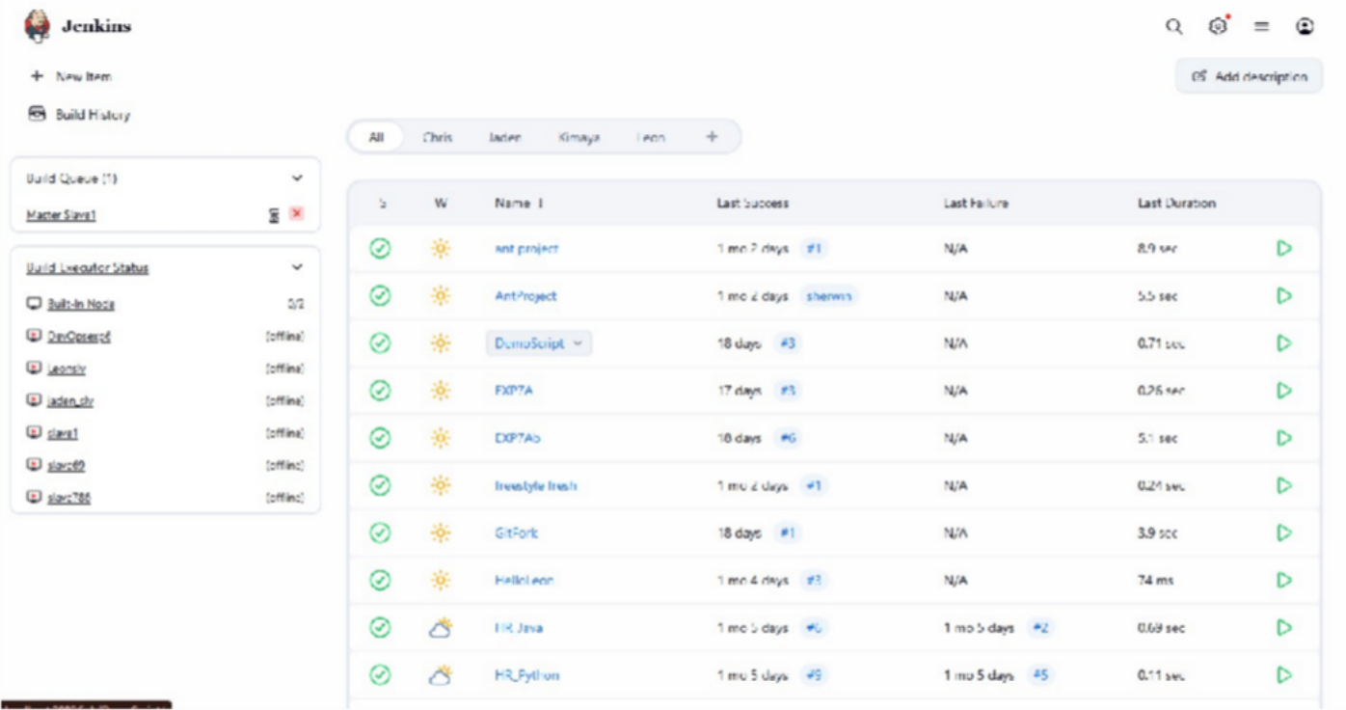

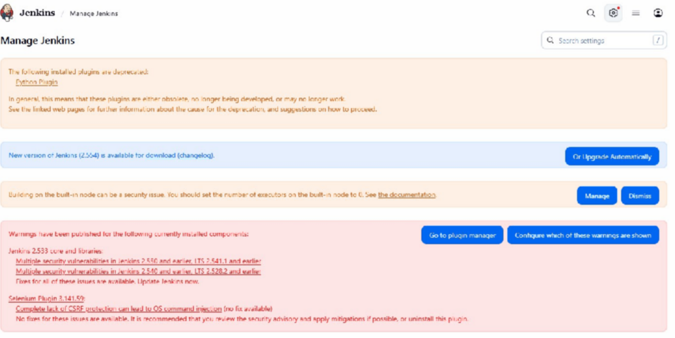
Click on plugins

Install plugin : Selenium and Selenium HTML Report
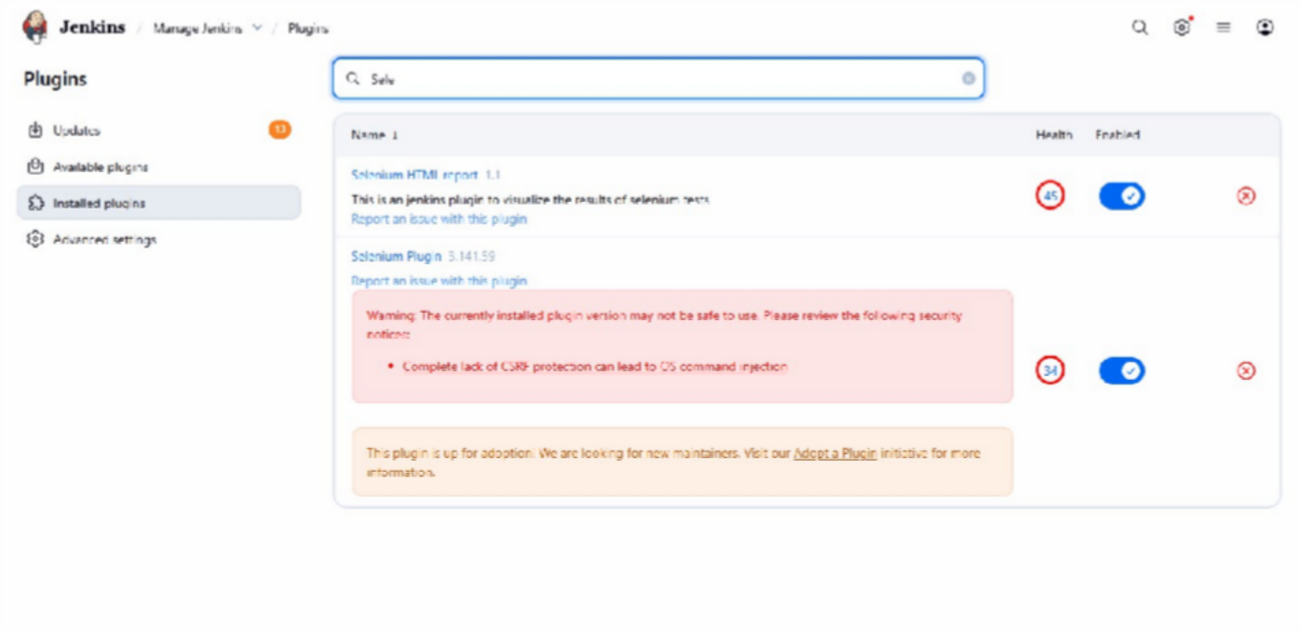

Jenkins More actions selenium grid
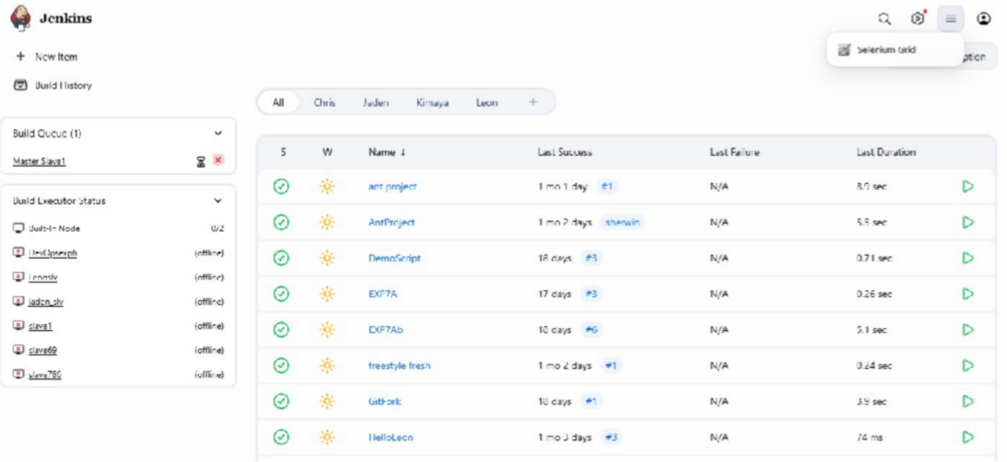

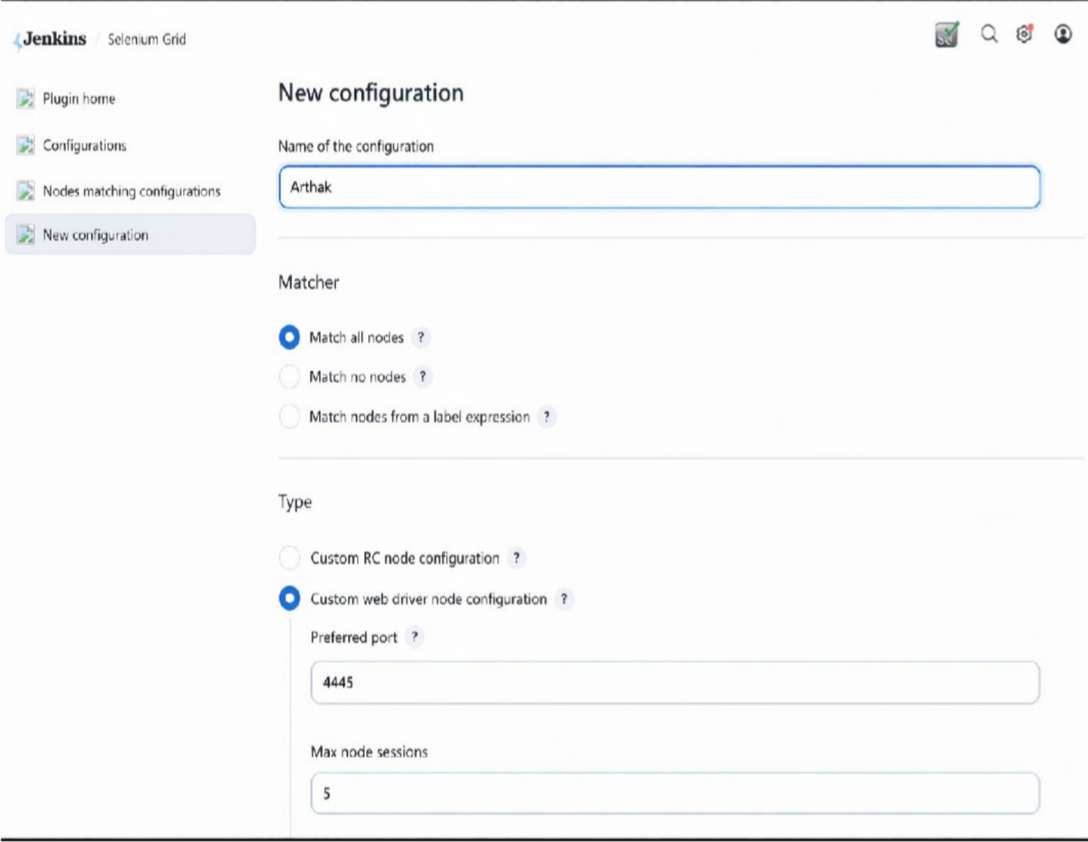

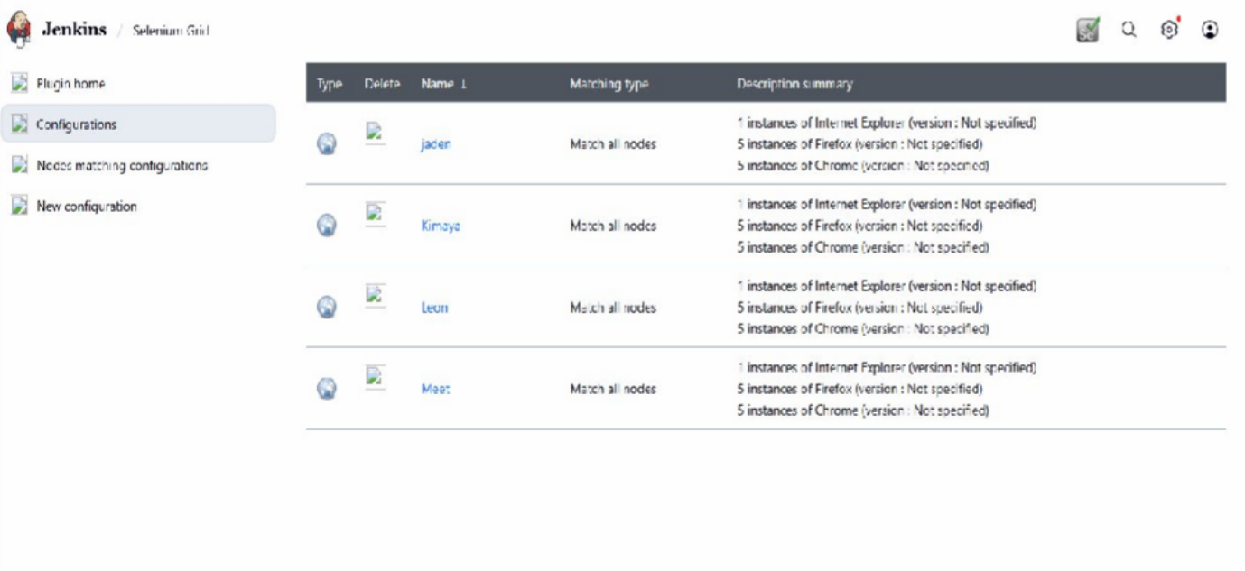
Save configuration

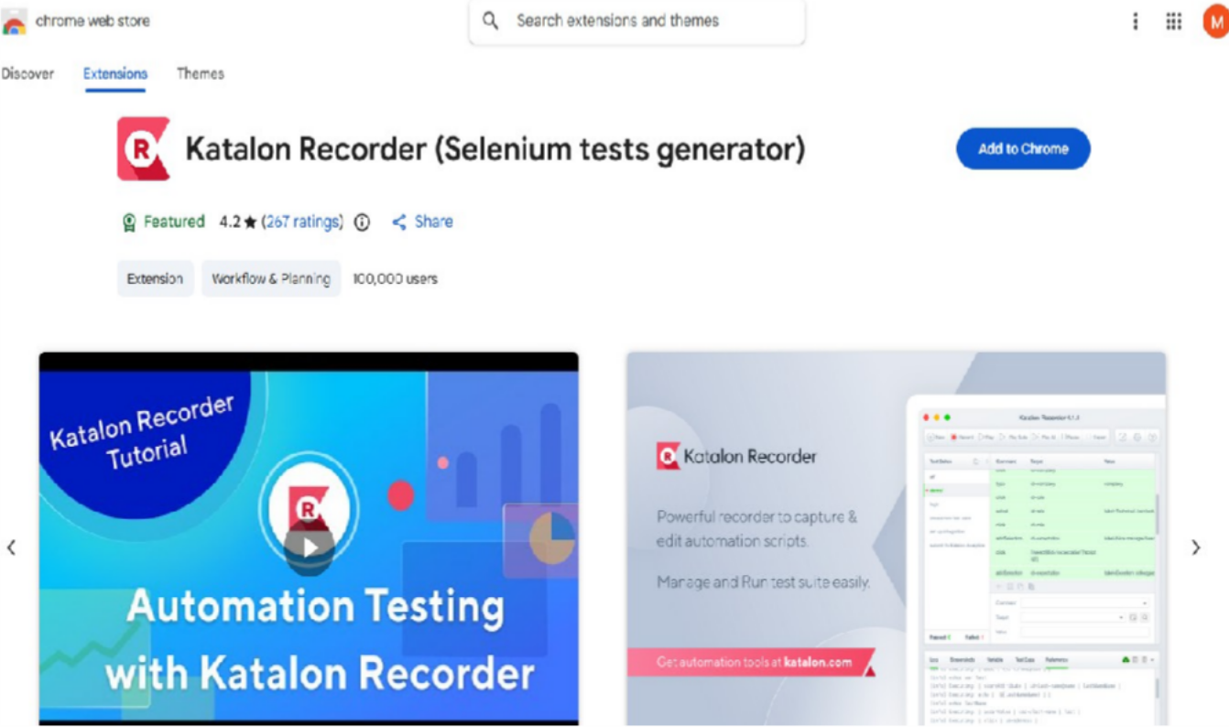
Add Extension, click on add to chrome

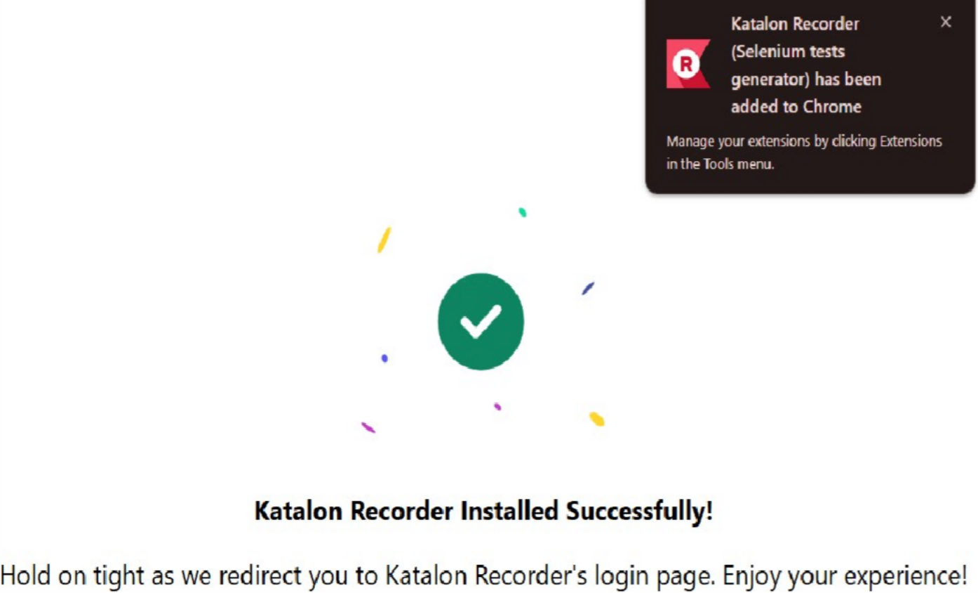

Katalon Recorder
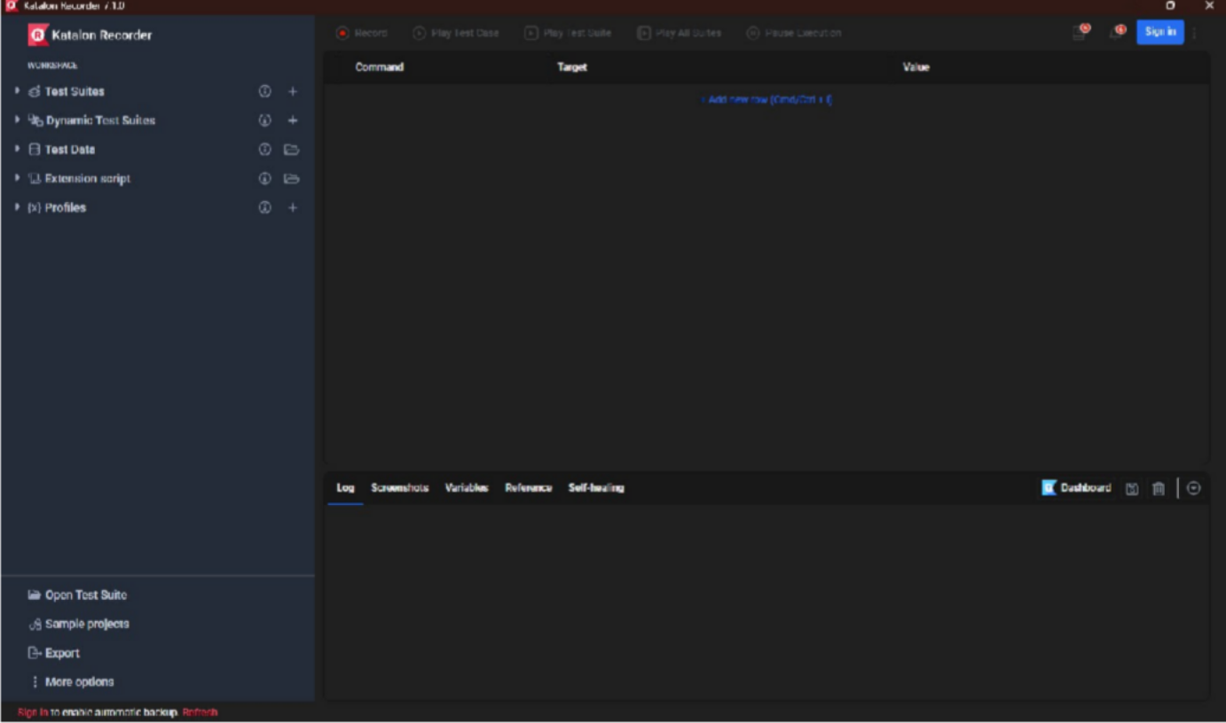

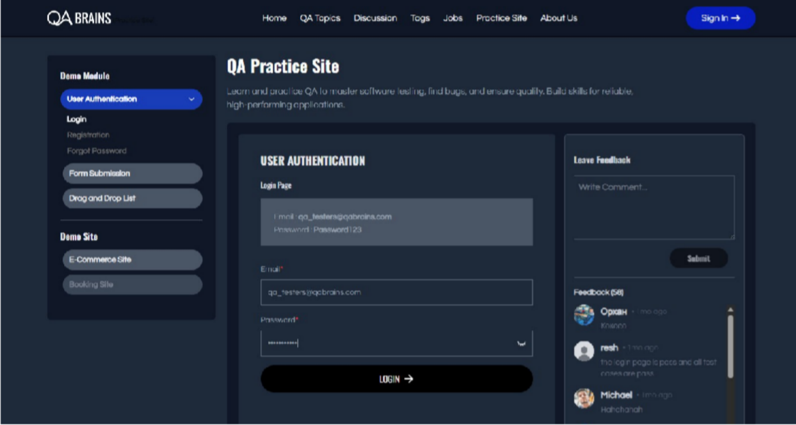
Go to website QA Brain Practice site Login with given username and password

Go to Katalon and press record button Click on Registration and fill all details
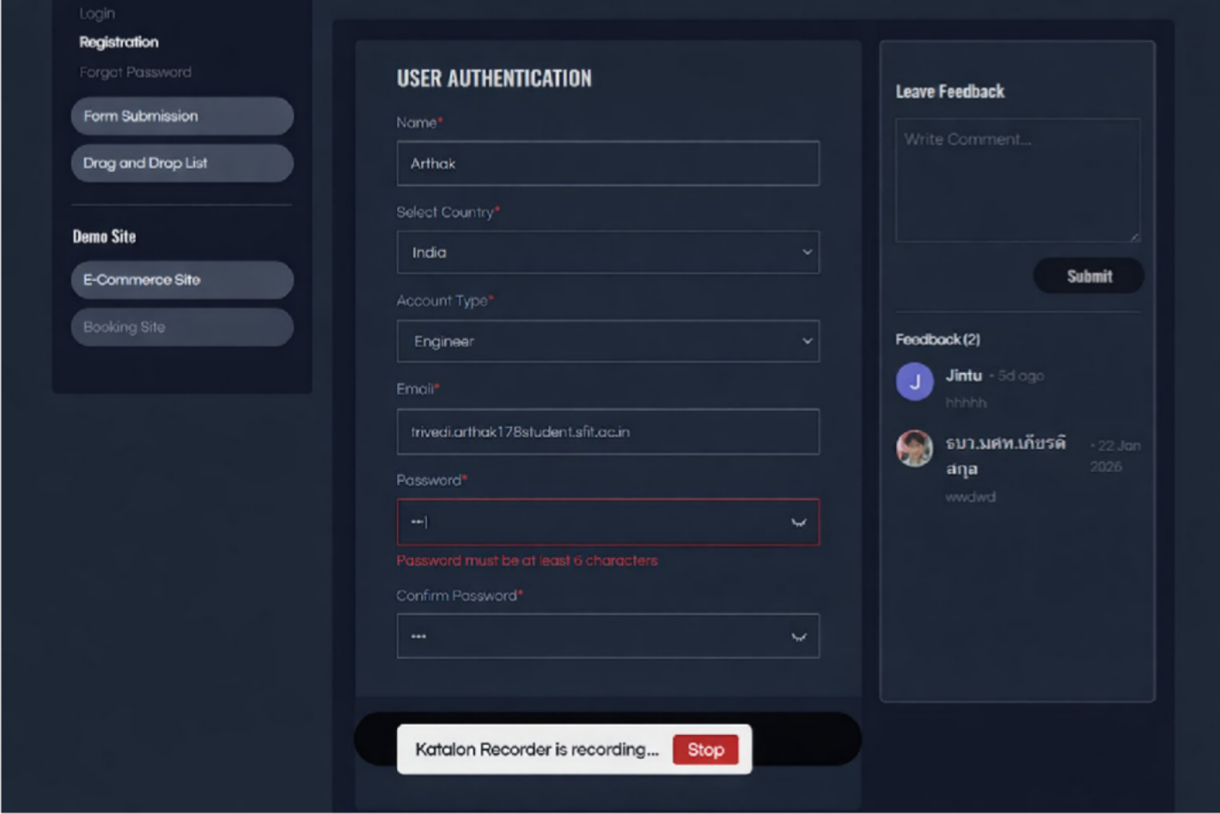

Make sure recording is on
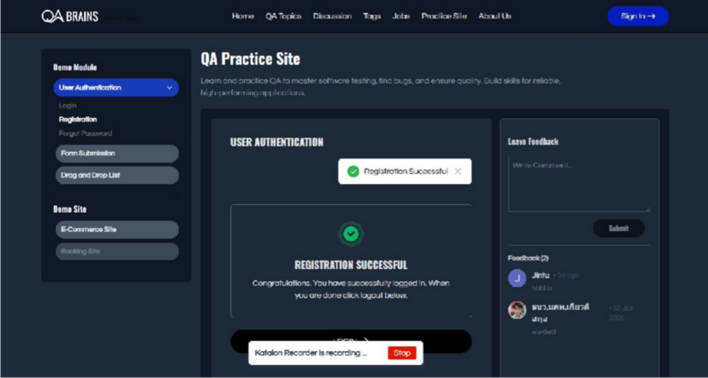

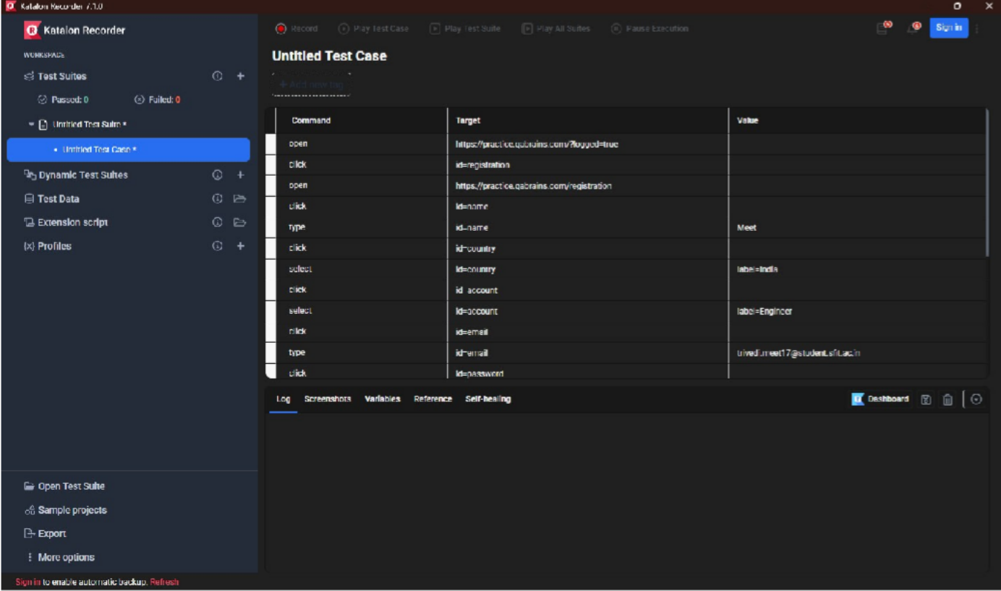
Stop the recording and play test cases Check Katalon Recorder

Click on play test cases Check the output
Test case Passed
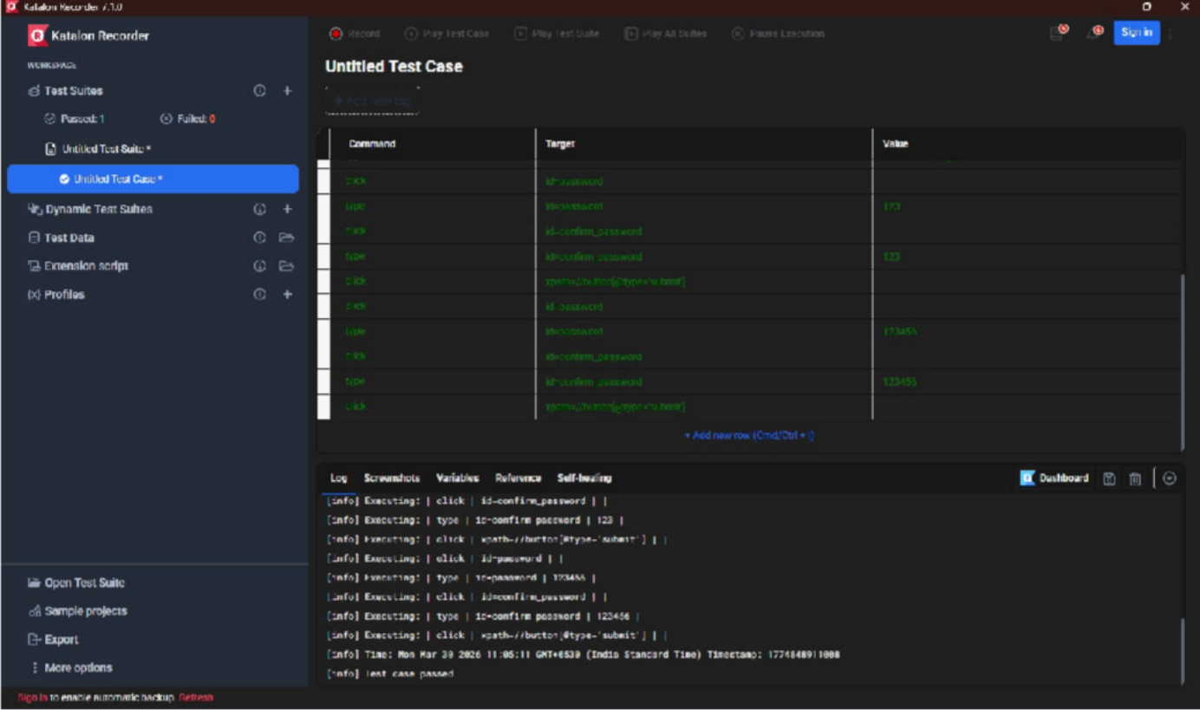

Go to Github and fork Slenium Project Practice repository
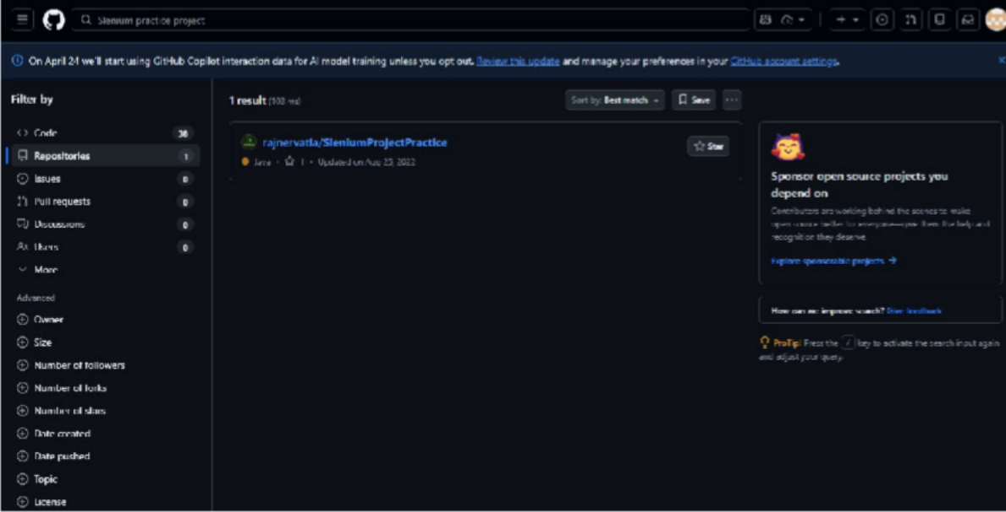
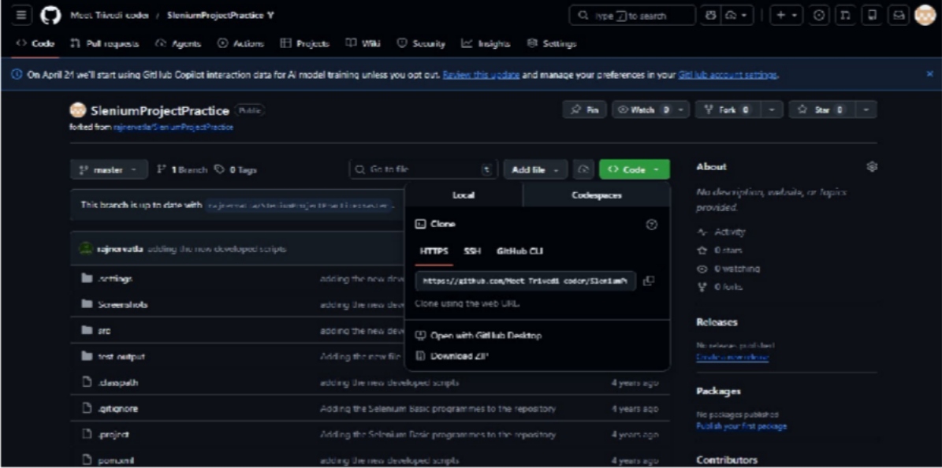

Copy URL
Go to Jenkins, New Project, Maven project
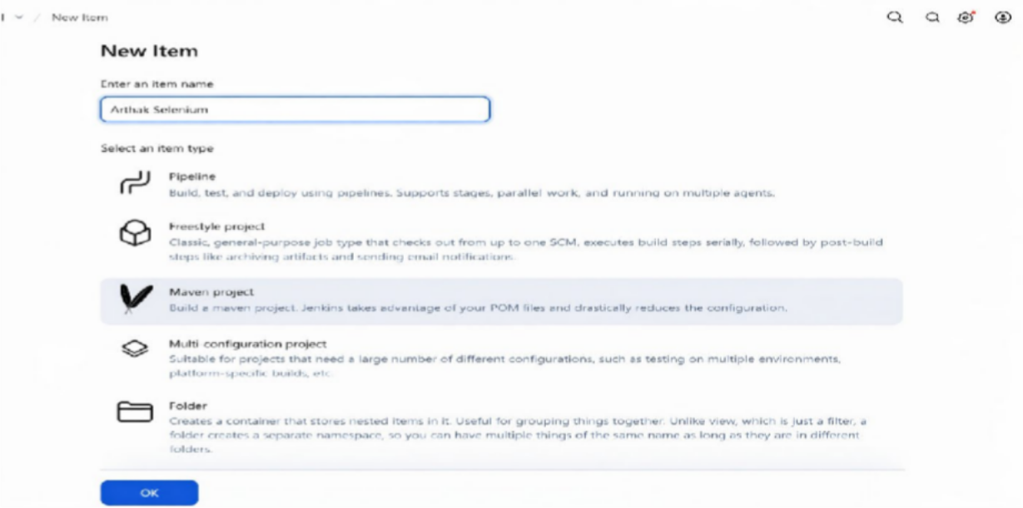

SCM : Git, Give Repository URL
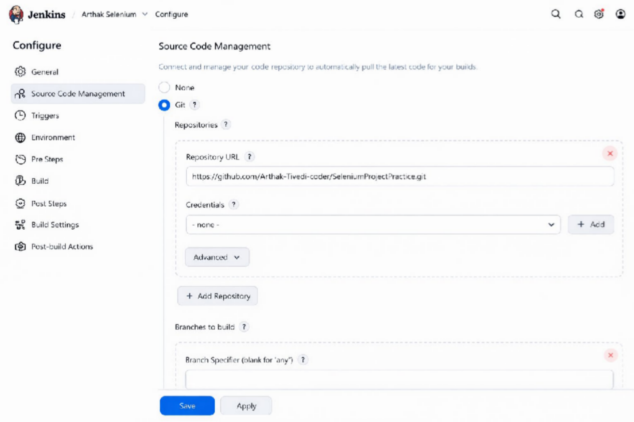

Build
Root POM : POM.XML
Goal and Options:
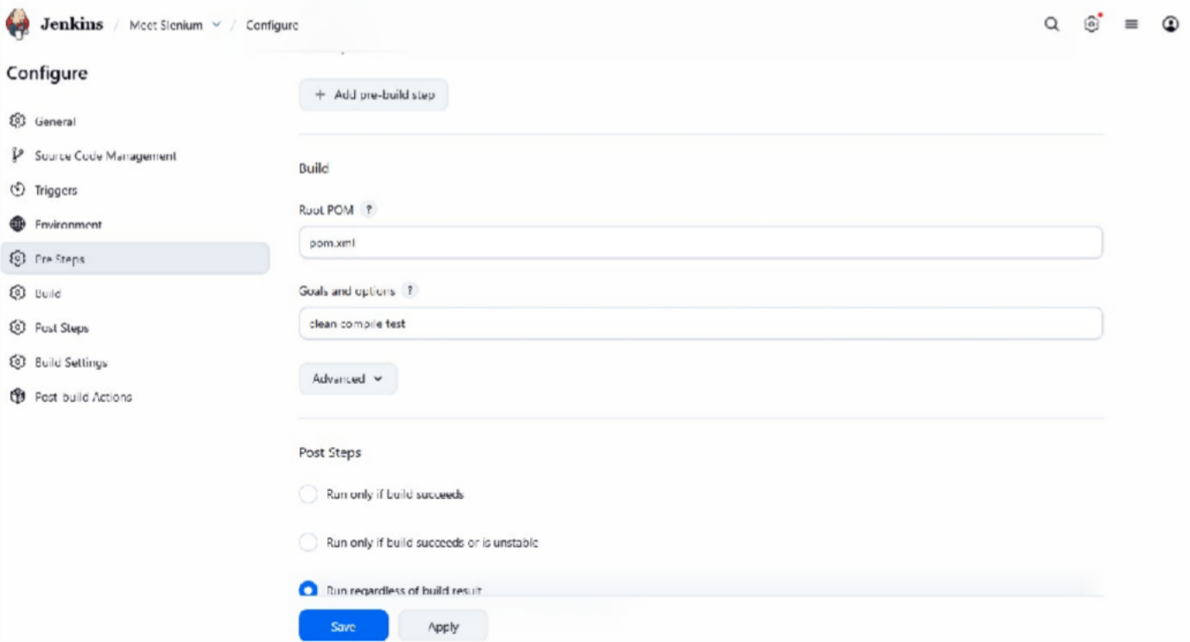
Clean, Compile and Test

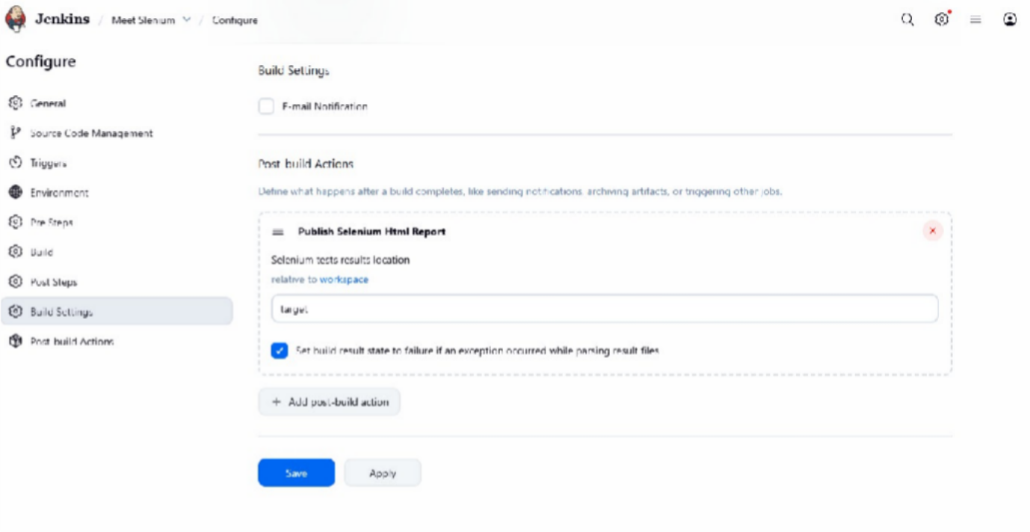
Post Build Action : Publish Selenium HTML Report Apply and Save

Build nOw
Check Console output
And selenium HTML Report
